The Crucial Role of Computer Science in Couture Jewellery Business and Theft Detection
Omer Gursoy

Author Note
Correspondence − omergursoy13@gmail.com / 5543@marlboroughcollege.org
This project was conducted independently of any organisation or business.
Acknowledgements
I would like to express my deepest thanks to Sevan Bicakci for his guidance to me in the couture jewellery sector, data scientist Naz Bayrak for her advice in the technical sections of this essay and lastly, my father Emin Gursoy for his unconditional support in my education.

Abstract
Jewellery design, especially in the art of couture jewellery, has a rich history and plenty of educational opportunities from a diversity of backgrounds. However, there are few systems in place to help designers find and counter the theft of their original designs. Computer science can help bridge this gap with the repurposing of visual search technologies already used in the field for customers to find visually similar designs. Using deep neural networks, a program may be written that analyses the photograph of a piece of jewellery and finds too-similar designs offered on sale from other designers without attribution or affiliation to the original designer. This program may be taught to differentiate between design theft and simple inspirational similarities that do not rise to the level of theft. The existence of such a technology can allow designers to protect themselves from financial loss by finding design thefts quickly and efficiently.
Keywords: computer science, jewellery sector, couture jewellery, design theft, deep neural networks, visual search

The Crucial Role of Computer Science in Couture Jewellery Business and Theft Detection
According to the Royal Academy of Fine Arts Antwerp, one of the most eminent educational institutes for art:
The human need to adorn, whereby jewels and objects are the main means of identification and expression, is universal and timeless. Jewels and portable objects tell a story about the status, style and culture of the wearer.
At the same time, they are a witness to social, cultural and technological developments. That's why jewellery design is such an exciting and versatile profession that, although based on a rich tradition of craftsmanship, is constantly changing. (“Jewellery Design & Gold- and Silversmithing”, n.d.)
Today, there are numerous bachelor’s and master’s that offer a comprehensive curriculum containing artistic studio practice as well as specific and general supporting theory courses for the development of artisanal skills. Besides, there are several vocational programs at associate or certificate levels. They all address educating talents in this timeless art form. Apart from these, exceptional people from different educational backgrounds pursue this art form as their family heritage and have strong names in the couture jewellery business with their signature designs. The designs of artists who graduated from jewellery design educational programs and artists from traditional backgrounds require urgent protection.
Even though some couture designs are nigh impossible to imitate because doing so would require specialised knowledge and skill as the techniques used are idiosyncratic to the original designer, there are still designs in the couture jewellery business which can be copied. Of course, we all know that a lot of artists get inspiration from each other’s work, and nothing is wrong with this. However, if this inspiration comes to the level of copying, it is a serious situation that should not be tolerated since it may cause a loss of motivation to create original works while also causing a serious financial loss to the original designer.
As a student who would like to pursue computer science with a good deal of experience in couture jeweller through my apprenticeship, I independently conducted research and noticed that although there are plenty of educational programs for jewellery artistry, there is a lack of training programs that concentrate on protecting the rights of designers working for couture jewellery. Therefore, I prepared this short introductory essay to support the artists working in jewellery both in my country and abroad while pointing out the prospective crucial role of computer science in this everlasting art form. Because I have a limited coding background, I discussed my entrepreneurial idea with a data scientist which caught her interest. She happily provided me with valuable technical information within the limitations of my understanding so I can share my idea with various audiences and draw a feasible framework for a possible solution.

How Computer Science Can Play a Role in Protecting Jewellery Design and Why It Might Be Beneficial
Thanks to the advancement of computer vision models in AI, it is now easy to inspect two different pictures and calculate a similarity between them within a fraction of a second. One of the most advanced techniques to achieve a similarity calculation is the use of deep neural networks. To find other pieces of jewellery with a similar design, it is possible to take a photograph of the original and run it through a database of other jewellery images to rank the most similar ones. This is one of the features of Google’s search engine and it enables customers to search for an image of an item they like and find shops that sell a similar item. I propose to re-purpose the technique behind this approach for protecting copyrights of jewellery and detecting counterfeits. The main advantages of using data science to attack this issue would be as follows:

Time
Today, detecting counterfeit designs does not have a formal approach and is mostly done by jewellery designers discovering works similar to their designs offered for sale by potential competitors. By this time, competitors who plagiarized the design might have already sold those pieces to a significant set of consumers profiting from a design they did not originally create. Once a deep learning model is taught to detect jewellery similarity down to specific parameters set by programmers searching for a counterfeit can be done within seconds and results can be presented on how much the found design looks like the original and who the seller of the found item is.

Ease of Use
Even though neural networks are complicated to build, the end users would only need to interact with a user interface which would enable them to upload a photo of their design and see if there are any copies already existing within the jewellery images dataset. Therefore, users would not need to know computer science or programming to benefit from such a search engine once it is created.

Reduced Human Error
In cases where experts have to determine whether a piece of jewellery is merely similar to the original or practically a copy of it, there may be differences of opinion. Neural networks calculate similarities in a mathematical method which is less open to interpretation. Due to the subjectivity of the situation, bringing a methodical approach to an interpretable area would reduce human error in the counterfeit detection process.

How Deep Learning Works to Detect Similar Designs
An image of jewellery would have many dimensions. To the human eye, it is very simple to extract its features like colour, shape and style. However, for computers, this is a very complex problem. Hence, neural networks start by taking an image with many dimensions and reducing it to characteristic features which are called feature vectors.
Figure 1
Neural Network Lowering Dimensions of a Car
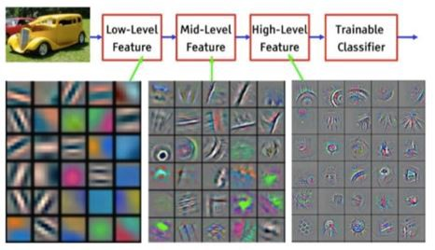
Note. From “Visualizing and Understanding Convolutional Networks” by M. D. Zeiler and R. Fergus, 2014, In D. Fleet, T. Pajdla, B. Schiele & T. Tuytelaars (Eds.), Computer Vision -- ECCV 2014, (pp. 818-833). Springer International Publishing.
Once we have the leanest feature vectors, we would use a metric to calculate the distance of our image vectors to all the other images in our database. One common approach would be using the cosine similarity which calculates the angles between images in a high-dimensional search space. The lower the angle between two images the higher the similarity between them would be.
Figure 2
Example of Cosine Similarity Calculation
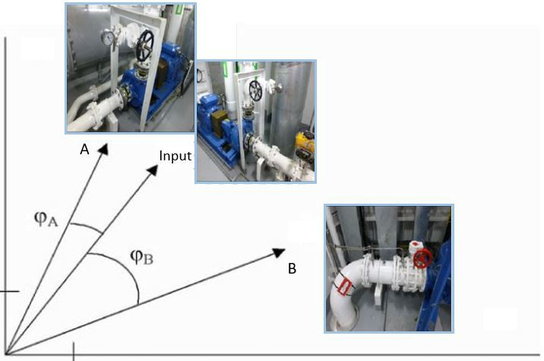
Note. Angle a is smaller and hence images are more similar compared to angle b. From “Deep Learning Based Reverse Image Search for Industrial Applications” by V. Flovik, 2020.
Finally, we would build a user interface that would allow users to upload a photo of their design. We would get the features from the photo and run it in a network of all jewellery images that are already in feature vector form. Finally, we would calculate the cosine similarity and sort them from smallest to largest. The top 5 results would be the main 5 designs that are most similar to the original, user-uploaded image in terms of design.
As well as the use of Cosine similarity, when the user interface is designed it is crucial to provide the right inputs to maximise accuracy. In the jewellery sector these may be features such as the colours of the piece, clarity of stone, the way in which the stones are faceted (the angles the stone is cut), and pattern matching. In addition, having the same background for every image is beneficial for fraud detection. For example, Cartier very recently carried out a project similar to mine. In Cartier’s model they used a “combination of classifiers”. Two of which are the colours and materials used for their watches in order to work out which collection the watch belongs to. Thereby, Cartier’s model’s accuracy went up to 96.5% and found items within three seconds. Therefore, we can withdraw that little details can make the big differences in accuracy.

Threshold Between Inspiration and Design Theft
Given our solution would always return a piece of similar jewellery we would have to establish a threshold value that defines a design as counterfeit. To achieve such a threshold value, we would look at already existing counterfeit designs and calculate their average cosine similarity. Assume we achieved X degrees as the threshold. In this case, if there are no search results lower than X degrees from our tool, we assume there are no copies of the design for the moment. If we do receive some potential counterfeits, then the designer can only review the potential copies and decides for himself if the other jewellery is a counterfeit or not.

Conclusion
There seems to be a lack of protection for designers from design theft. Computer science offers an avenue for quick detection of design theft via similarity searching in image databases using deep neural networks. Existing visual search technologies already in use that allow customers to find similar pieces of jewellery online can be repurposed and trained specifically to detect design theft by way of setting an algorithmically calculated threshold between acceptable and unacceptable levels of similarity using previously established design theft cases, removing to a degree human error. If this search and detection technology is coupled with a simple user interface as well, designers can have an easy time using this software and be readily given a report on too-similar jewellery pieces on sale by other sellers, allowing the original designers to decide for themselves if their design is stolen and how to act on the knowledge.

References
Flovik, V. (2020, October 26). Deep learning based reverse image search for industrial applications. Towards Data Science. Retrieved September 8, 2022, from https://towardsdatascience.com/deep-learning-based-reverse-image-search-for-industrial-applications-33ba4b0d32c4
Nawalgaria, A. &Erfurt, A. (April 6, 2021). AI in retail: Google Cloud transforms Cartier’s product search technology. https://cloud.google.com/blog/products/ai-machine-learning/ai-retail-google-cloud-transforms-cartiers-product-search-technology
Royal Academy of Fine Arts Antwerp. (n.d.). Jewellery Design & Gold- and Silversmithing. Retrieved September 8, 2022, from https://www.ap-arts.be/en/education/jewellery-design-gold-and-silversmithing
Zeiler, M. D., & Fergus, R. (2014). Visualizing and understanding convolutional networks. In D. Fleet, T. Pajdla, B. Schiele & T. Tuytelaars (Eds.), Computer Vision -- ECCV 2014, (pp. 818-833). Springer International Publishing.

